The Project | Research title | Effect of positive expiratory pressure on symptoms, extravascular lung water accumulation and cardiovascular function at high altitude. (How does wearing a mask which makes breathing out more difficult affect us at altitude?)
The Project | Expedition & year | Medex Medical Expedition Manaslu 2015
The Project | Project funders | Medex Medical Expedition, PETZL Foundation, French Alpin Federation
The Project | Aim of project | To assess the effect of breathing with an added expiratory resistance at high altitude on body oxygenation and mechanisms of adaptations to high altitude
Project staff | Principal Investigator | Samuel Verges
Project staff | Collaborators | Thomas Rupp, Guillaume Walther, Claire Maufrais, François Estève, Pierre Bouzat
Project staff | Institutes involved | Grenoble Alpes University, Savoie Mont-Blanc University, Avignon University, INSERM, Grenoble Alpes University Hospital
Data collection | What did your participants have to do? | Participants breathed for 1h30 with a specific mask which makes breathing out harder, at sea level and at high altitude. While breathing with the mask, several sensors recorded their breathing, blood and tissue oxygenation, brain perfusion, fluid accumulation in the lungs and cardiac function. In addition, they filled questionnaires regarding their perception of breathing and their acclimatisation to high altitude.
Data collection | What data did you collect? | Changes induced by the mask regarding body oxygenation, brain perfusion, cardiac function, lung water and individual estimation of altitude acclimatisation
Photos | Attach 2 photos of research in action. | 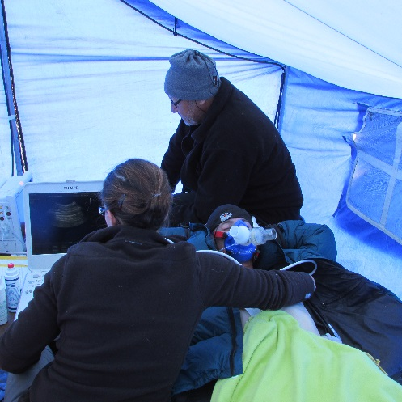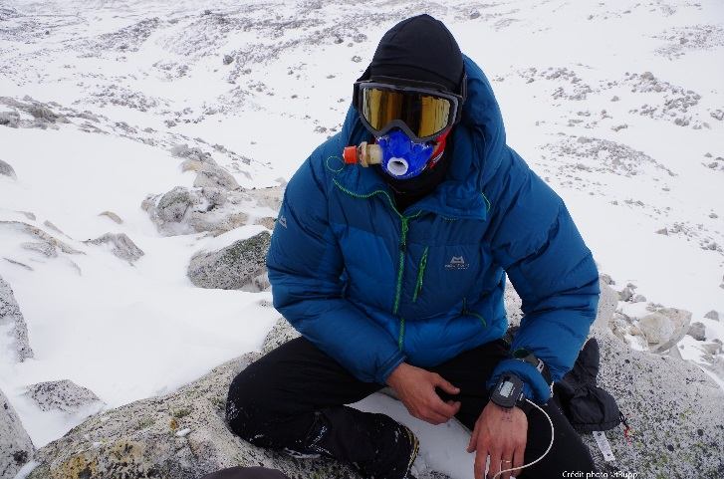
Photos | Photo captions | Picture 1: A subject breathing through the mask with ongoing physiological recordings  Picture 2: A subject using the mask during a climb in the mountains
Photos | Who took the photos? | Samuel Verges, Guillaume Walther
The results | What did you find out? | At altitude, the mask which made breathing out harder and affected the breathing pattern increased tissue and blood oxygenation, without adverse effects on the heart and the brain.
The results | What are the implications of your findings (e.g. for altitude medicine)? | This kind of mask may become a new method to improve oxygenation and adaptation to high altitude.
Sharing the results | At what conferences have the findings been presented? | Presented at Birmingham Medical Research Expeditionary Society Biannual Meeting. 26 November 2016.  Presented at Hypoxia 2017. 7 – 12 February 2017.
Sharing the results | What peer reviewed papers have been published? | No publication yet.
Sharing the results | What books or lay publications have been published? | Nothing yet.
The future | What plans do you have to use the data in the future? | Data will be submitted for publication in international journals.
The future | What do you think should be researched next? | The efficiency of this mask for subjects with moderate to severe acute mountain sickness should be tested and compared to alternative methods such as hyperbaric chamber.
The future | Any other comments / advice for others?

